The Tools and Techniques of Field Work
When you picture a scientist at work, what tools come to mind? Bunsen burners, goggles, and test tubes? In reality, scientists use an incredibly wide array of tools to collect data. Some of these tools are multimillion dollar machines, and others are simple homemade devices. A tool may weigh one hundred pounds or be lighter than a penny. No matter how they differ, one thing is certain: all scientific tools must be carefully matched to a scientist’s needs.
If you pictured Bunsen burners and white lab coats earlier, you were picturing lab work. Lab work is an important component of scientific research because scientists have a lot of control over the lab environment. Another type of research is field work. When scientists do field work, they go out into a natural environment in order to collect data. As you can imagine, this can be tricky because of challenges from the weather, animals, plants, and terrain. Even though it’s difficult at times, field work is often a lot of fun!
You are about to take a tour through the cloud forests of Monteverde, Costa Rica, to see field work in action using the Canopy in the Clouds website (www.canopyintheclouds.com). Use this handout as a guide, and fill in the accompanying data table as you go along. You will need to pay close attention to the names of the tools that are being used and the techniques that the scientist uses when implementing each tool. (In some cases, no technical name is given for the tool, so you can do your best to describe it instead of naming it.) Finally, you will need to describe the type(s) of data that can be collected with the help of each tool. It is very common to need to watch a video clip two or more times in order to gather all of the information you need, so don’t hesitate to replay the clips! The first row of the data table has been completed for you as an example.
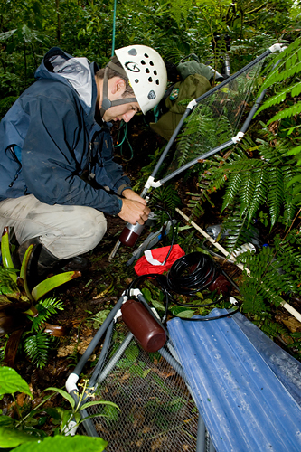
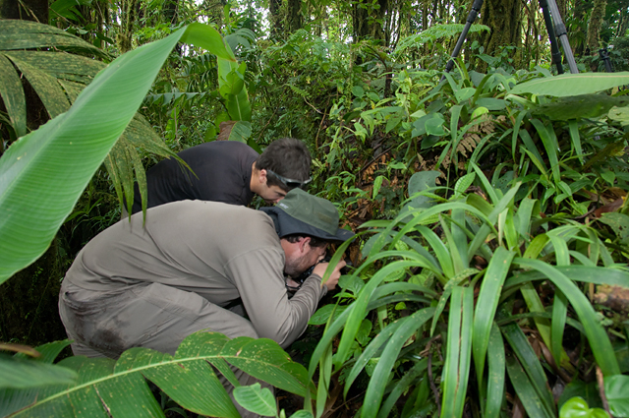
Panorama | Hotlink | Tool | How the tool is used | Data that can be collected with the help of this tool
1  (Low Elevation Forest) | 3  (ground) | Shovel | A few people use it to dig a deep hole in the forest. The hole is large enough for someone to stand in and about knee-deep. | Soil structure, biomass of plant roots, water content, and nutrient concentrations of soil

Panorama | Hotlink | Tool | How the tool is used | Data that can be collected with the help of this tool

When your data table is complete, please answer the following questions. You may revisit any panoramas as necessary.
1. Select two tools that you included on your data table and for each, explain one apparent (or potential) strength and one apparent (or potential) weakness. These strengths and weaknesses may not have been discussed in the video clips. You’ll need to use your own thoughts. Please use full sentences and explain your reasoning.
Tool #1: __________________________________________________
Apparent/potential strength: ______________________________________________________________
_____________________________________________________________________________________
_____________________________________________________________________________________
_____________________________________________________________________________________

Apparent/potential weakness: ____________________________________________________________
_____________________________________________________________________________________
_____________________________________________________________________________________
_____________________________________________________________________________________

Tool #2: __________________________________________________
Apparent/potential strength: ______________________________________________________________
_____________________________________________________________________________________
_____________________________________________________________________________________
_____________________________________________________________________________________

Apparent/potential weakness: ____________________________________________________________
_____________________________________________________________________________________
_____________________________________________________________________________________
_____________________________________________________________________________________
As you were exploring the cloud forest, you were collecting information about how scientists conduct field work. Whenever a scientist is conducting research, he or she uses the inquiry process. The inquiry process includes several important components:
-Asking a question
What type of frogs, if any, live in the elfin forest of Monteverde?
-Making a plan
I can visit the elfin forest and look for frogs. I may have to look on the ground as well as on trees or in the upper canopy, and I will have to look during all hours and weather conditions. I can also compare my data with that of people who are experts on tropical frogs.
-Gathering information (data) related to the question
Use a field journal to record observations. Take photographs and make audio recordings when possible.
-Examining the data
I only found evidence of three types of frogs in the elfin forest. All of these were frogs that I saw between 12 A.M. (midnight) and 3 A.M. The frogs appeared to be a similar size, but two were brightly colored and one was drab.
-Drawing conclusions
It seems that some frogs do live in the elfin forest, but I do not have enough information to say how many, exactly. My data also indicate that frogs that live in the elfin forest are most active late at night and in the early hours of the morning. I need much more data in order to learn more about the elfin forest frogs!
The example above is a very simple one. Sometimes research goes in this order, but oftentimes it does not! A scientist may ask a question, make a plan, and start to gather information, then come up with a different (often better) research question during the information gathering stage. That means they have to create a new plan, gather more information, et cetera. This is still the inquiry process! Scientific research can unfold in many ways, which allows scientists to make the most of their ideas and resources.
Think back to what you saw and heard as you toured the cloud forest canopies. For each component of the inquiry process, identify one hotspot and explain why you chose it as an example of that component. Identify one hotspot and explain which components of the inquiry process it contains. You must include at least two examples. Remember, you are looking for evidence of:
-Asking a question
-Making a plan
-Gathering information (data) related to the question
-Examining the data
-Drawing conclusions

1. Component (see list on previous page): ___________________________________________________
Panorama # ______; hotspot # ______
Explanation: __________________________________________________________________________
_____________________________________________________________________________________

2. Component: ________________________________________________________________________
Panorama # ______; hotspot # ______
Explanation: __________________________________________________________________________
_____________________________________________________________________________________

OPTIONAL:
3. Component: ________________________________________________________________________
Panorama # ______; hotspot # ______
Explanation: __________________________________________________________________________
_____________________________________________________________________________________

4. Component: ________________________________________________________________________
Panorama # ______; hotspot # ______
Explanation: __________________________________________________________________________
_____________________________________________________________________________________

5. Component: ________________________________________________________________________
Panorama # ______; hotspot # ______
Explanation: __________________________________________________________________________
_____________________________________________________________________________________

